All stainless steel rain sensor
(Model 485)

Pr-yl-n01-3005
VER 2.0

Table of contents
Chapter 1 introduction
1.1 product overview
1.2 functional features
1.3 key technical indicators
1.4 product selection
1.5 product appearance
2.1 equipment inspection before installation
2.2
2.2.1 sensor wiring
2.3 outdoor installation and commissioning
2.3.1 Create Installation Base
2.3.2 install stationary equipment and adjust the level of the storm drain
2.3.3 adjust the rain gauge level
3.1 the sensor is connected to the computer
3.2 use of sensor monitoring software
Chapter 4 Communication Protocol
4.1 basic communication parameters
4.2 data frame format definition
4.3 register addresses
4.4 examples and explanations of communication protocols
4.4.1 enquire the current total rainfall value
4.4.2 remove rainfall data
4.4.3 modify current address
4.4.4 modifies the current baud rate
4.4.5 query address
Chapter 5 maintenance and maintenance
Daily Maintenance
5.2
Chapter 6 common problems and solutions

Chapter 1 product introduction

1.1 product overview
The instrument is a primary instrument for precipitation measurement, its performance meets the national standard GB/T 21978.2 -2014“Precipitation observation requirements” requirements.
The core part of the device is a three-dimensional streamlined design, all stainless steel material, so that the tipping bucket more fluid, and with self-washing dust, easy to clean the function. The 485 pulse output signal can read the rainfall directly without second calculation, which is simple and convenient.

1.2 functional characteristics
As shown in Figure 1, the instrument consists of rain gauge shell, rain collector, funnel, bucket support, bucket, bearing screw, water outlet bin, sealing joint, Reed tube, level bubble, adjusting support plate, control box, leveling device, terminal, leg support, rain gauge base, etc. . The rain gauge base is provided with a dump shaft, a round horizontal bubble, a reed pipe bracket and a signal output terminal. Different from other dump type rain gauge, the dump shaft sleeve of this instrument is an integrated positioning structure, the dump is installed in the bearing through the dump shaft, and the internal structure of this instrument is assembled when it leaves the factory, there is no need to install the internal structure on-site, which brings convenience to the on-site installation.
The tipping bucket of this instrument is designed for three-dimensional streamline, and designed with drooping arc guide tip, its shape is beautiful and smooth, turn over water performance is better and easy to clean and maintain.
A permanent magnet steel is arranged on the dumper of the instrument, and a reed tube is arranged on the reed tube bracket. When the instrument leaves the factory, the magnet steel and the reed tube have been adjusted to a suitable coupling distance, the output signal of the instrument has a definite proportional relationship with the turning times of the tipping bucket.
When the instrument leaves the factory, the tipping angle adjusting screw has been locked at the best base point of the tilt angle and the tilt angle screw has been sealed with red paint, when the user installs the instrument on the spot, he only needs to adjust the horizontal bubble to the center position according to the related requirements of this manual.
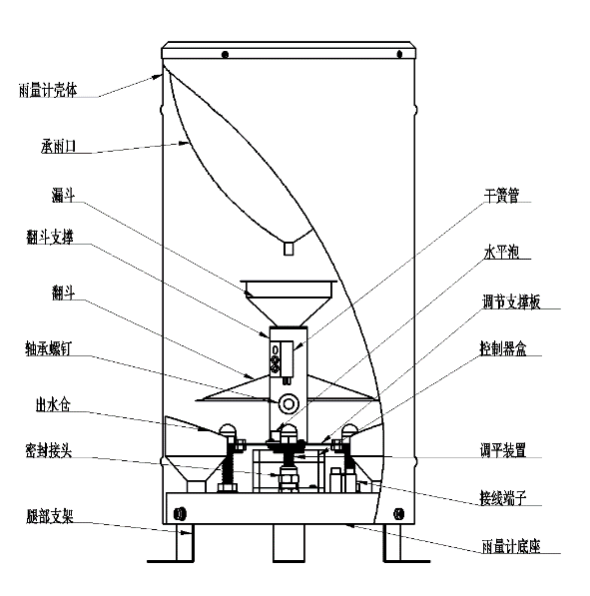
Figure 1

1.3 key technical indicators
Diameter of bearing rain: φ200mm; sharp edge angle: 40 ° ~ 45 °
Resolution: default 0.2 mm, optional 0.1/0.5 mm
Typical accuracy: ≤ ± 4% (indoor precipitation, based on instrument displacement)
Rainfall intensity range: 0mm ~ 4mm/min (maximum rainfall intensity allowed is 8mm/min)
Communication: 485 communication (standard ModBus-RTU protocol)
Power supply: 4.5 ~ 30V Max Power Consumption: 0.24 W working environment:
Ambient Temperature: 0-55 ° C RH: < 95% RH (40 ° C)

1.4 product selection
Note: Please buy the supporting plate separately.
PR - |  |  |  |  | Company code name
 | YL- |  |  |  | Rain gauge
 |  | N01 - |  |  | 485(Modbus protocol) output
 |  |  | 3005 - |  | All stainless steel
 |  |  |  | 01 | 0.1 mm
 |  |  |  | 02 | 0.2 mm
 |  |  |  | 05 | 0.5 mm

1.5 product appearance
Chapter 2 hardware connectivity

2.1 equipment pre-installation inspection
(1) take the instrument out of the packing box, check the packing list according to the instruction and check whether the accessories are complete.
(2) read the instruction manual and the product certificate carefully.
(3) inspect the appearance of the equipment for damage, in particular to check whether the tipping bucket is intact, and pay attention to place the tipping bucket properly to prevent damage to the shaft tip of the tipping shaft and the arc-shaped water diversion tips at both ends of the tipping bucket; And do not touch the inner wall of the tipping bucket with your fingers to avoid fouling the tipping bucket to damage the accuracy of the instrument.
(4) unscrew the three screws at the bottom of the equipment, take the stainless steel outer cylinder, cut off the tie belt fixing the Flip Bucket, then install the outer cylinder, the preparation work is finished.
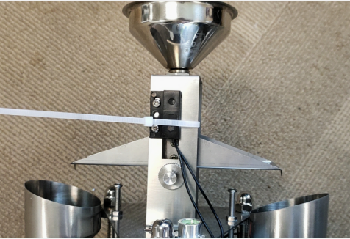

2.2
Power Interface 4.5-30V for wide voltage input. 485 signal line wiring attention to A-B two lines can not be connected back, the bus address between multiple devices can not conflict.

2.2.1 sensor wiring

Line color | Description | Line color | Description
Brown Line | The power supply is positive | Yellow Wire | 485A
Black line | The power supply is negative | Blue Wire | 485B

2.3 outdoor installation and commissioning
2.3.1 make the Installation Base
When installing the outdoor ground and roof, the cement foundation should be made according to the size and requirement of Fig. 2. The plane of the cement foundation should be horizontal. The size of the cement installation foundation is generally not less than 30 cm in height of 40 cm × 40 cm square base or diameter of 40 cm circular base. The distance between the height of the instrument's rain-bearing mouth and the ground level is 70cm, and no shelter above the instrument's rain-bearing mouth is allowed within 3-5 meters.
2.3.2 install stationary equipment and adjust the level of the storm drain
Make 3 φ10 deep 8-10 cm mounting holes on the cement base according to the size of Fig. 2, place the expansion bolt in the mounting holes, lock it with the locking nut, then install the instrument base on the 3 adjusting support nuts, by adjusting the height of the support nut and using a level ruler to measure whether the ring is in a horizontal state, and finally use the lock to fix the instrument.
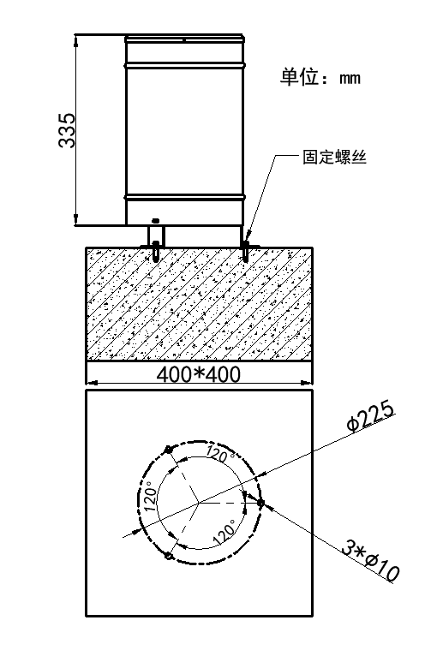

Figure 3
2.3.3 adjust the rain gauge level
Take off the stainless steel outer cylinder, in Figure 3, the dome nut is not locked, just adjust the height of the nut in the red circle with 2 hands respectively, so that the bubble in the horizontal bubble is in the center position, then lock the dome nut, again check and adjust the bucket support on the level of the bubble is located in the middle of the bubble can be.
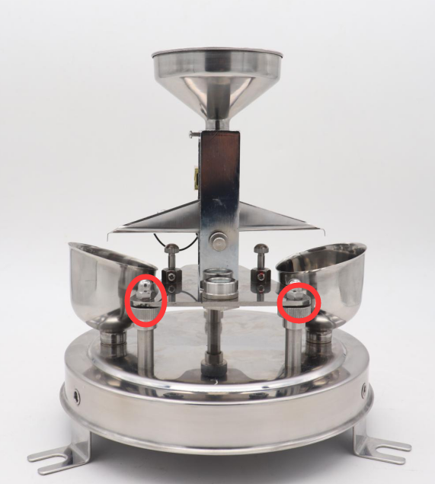
Figure 4

Chapter 3 configuration software installation and use
We provide the supporting“485 parameter configuration software”, can easily use the computer to read the parameters of the sensor, while flexible modification of the sensor device ID and address.
Note that using software for automatic acquisition requires ensuring that there is only one sensor on the 485 bus.

3.1 the sensor is connected to the computer
After connecting the sensor to the 485 via USB and powering it properly, you can see the correct COM port on your computer (see the COM port in my pc-properties-device manager-port) .
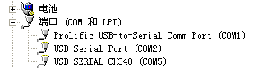
Open the package, select“Debugging software”-“485 parameter configuration software”, find to open.
If you do not find a COM port in device manager, it means that you do not have a USB to 485 driver installed (in the package) or you do not have the driver installed correctly, please contact a technical person for help.

3.2 use of sensor monitoring software
Configuration interface as shown in the figure, first according to Section 3.1 method to get the serial port number and select the correct serial port.
Click on the test baud rate of the software, the software will test the current device baud rate and address, the default baud rate is 4800 bit/s, the default address is 0x01.
3. Change the address and baud rate as needed, and query the current function status of the device.
If the test is not successful, please re-check the wiring and 485 driver installation.
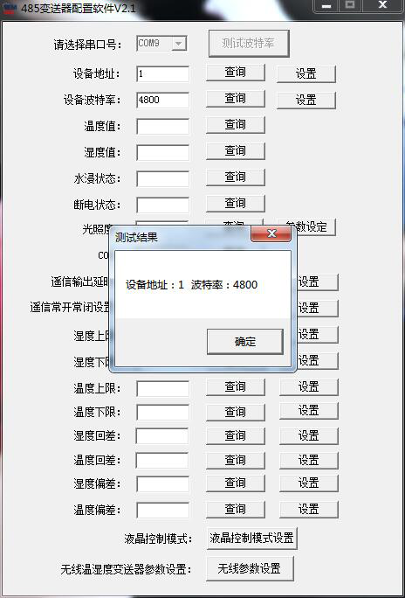

Chapter 4 Communication Protocol

4.1 basic communication parameters
Code | 8-bit binary
Data bits | 8 bits
Parity bit | 无
Stop bit | 1
Error checking | CRC (redundant cyclic code)
Baud rate | 1200bit/s, 2400bit/s, 4800bit/s, 9600bit/s, 19200bit/s, 38400bit/s, 57600bit/s, 115200bit/s can be set

4.2 data frame format definition
Using ModBus-RTU protocol, the format is as follows:
Initial structure ≥4 bytes of time
Address code = 1 byte
Function code = 1 byte
Data area = N bytes
Error Check = 16-bit CRC code
Time to end structure ≥4 bytes
Address Code: the address of the transmitter, which is unique in the communication network (factory default 0x01) .
Function code: the instruction function instruction issued by the host computer.
Data area: Data area is the specific communication data, note 16bits data high bytes in front!
CRC code: two-byte checksum code.
Host queries frame structure:
Address Code | Function codes | Register start address | Register length | Low checksum | High checksum
1 byte | 1 byte | 2 bytes | 2 bytes | 1 byte | 1 byte
Slave reply frame structure:
Address Code | Function codes | Number of valid bytes | Data Area One | Second data area | The N data area | Check Code
1 byte | 1 byte | 1 byte | 2 bytes | 2 bytes | 2 bytes | 2 bytes

4.3 register addresses
Register address | Contents | Operation (hexadecimal) | Scope contents and definitions
0000H | Rainfall value | 0x03/0x04/0x06 | Rainfall, 10 times larger than it actually was
07D0H | Device address | 0x03/0x04/0x06/0x10 | 1-254(factory default 1)
07D1H | Device Baud rate | 0x03/0x04/0x06/0x10 | 0 represents 24001 represents 4800  Two for 96,003 for 19,200  4 represents 384,005 represents 57,600  Six is 1152007 is 1200

4.4 examples and explanations of communication protocols

4.4.1 find the current total rainfall value
Frame of inquiry:
Address Code | Function codes | Start Register | Data Length | Low checksum | High checksum
0x01 | 0x03 | 0x000x00 | 0x000x01 | 0x84 | 0x0A
Response Frame:
Address Code | Function codes | Returns the number of valid bytes | Rainfall value | Low checksum | High checksum
0x01 | 0x03 | 0x02 | 0x000x0a | 0x38 | 0x43
Current total rainfall: (10x larger)
000A (base 16) = 10(decimal)→ Rainfall: 1.0 mm

4.4.2 clear rainfall data
Frame of inquiry:
Address Code | Function codes | Start Register | Clear Command | Low checksum | High checksum
0x01 | 0x06 | 0x000x00 | 0x000x5a | 0X09 | 0XF1
Response Frame:
Address Code | Function codes | Start Register | Clear Command | Low checksum | High checksum
0x01 | 0x06 | 0x000x00 | 0x000x5a | 0X09 | 0XF1

4.4.3 modify the current address
Query frame: (if the current address is 01, change the address to 02)
Address Code | Function codes | Starting address | Modify values | Low checksum | High checksum
0x01 | 0x06 | 0x070xd0 | 0x000x02 | 0x08 | 0x86
Response Frame:
Address Code | Function codes | Starting address | Modify values | Low checksum | High checksum
0x01 | 0x06 | 0x070xd0 | 0x000x02 | 0x08 | 0x86

4.4.4 modifies the current baud rate
Query frame: (if the current baud rate is 4800 modified to 9600)
Address Code | Function codes | Starting address | Modify values | Low checksum | High checksum
0x01 | 0x06 | 0x070xd1 | 0x000x02 | 0x59 | 0x46
Response Frame:
Address Code | Function codes | Starting address | Modify values | Low checksum | High checksum
0x01 | 0x06 | 0x070xd1 | 0x000x02 | 0x59 | 0x46

4.4.5 enquiry address
When the user forgets the address, he can use the following function code to find the address.
Frame of inquiry:
Address Code | Function codes | Starting address | Data Length | Low checksum | High checksum
0xFF | 0x03 | 0x070xd0 | 0x000x01 | 0x91 | 0x59
Response Frame
Address Code | Function codes | Returns the number of valid bytes | Address | Low checksum | High checksum
0xFF | 0x03 | 0x02 | 0x000x01 | 0x50 | 0x50
The address code read is the actual address of the device: 01

Chapter 5 maintenance
5.1 routine maintenance
The instrument has been outdoors for a long time and is used in a rather harsh environment. Therefore, the inside wall of the rain-bearing opening of the instrument should always be wiped with a soft cloth to keep the rain-bearing opening clean. If any foreign objects such as leaves are found in the rain-bearing opening, the inside of the rain-bearing opening should be cleaned in a timely manner, keep the waterways clear. When the equipment is not in use for a long period of time, a cover should be put on the equipment ring to protect the rain bearing opening;
Instrument long-term work generally one month to clean once, three months must clean once;
5.2 dump cleaning
Dumper is the key component of the instrument, it directly affects the accuracy of the instrument, over time, the dumper wall will deposit a little dust or oil, therefore, the dumper should be cleaned. When cleaning, can use clear water to rinse the inside wall of the dumper repeatedly clean or gently brush with a degreasing brush, do not use hands or other objects to wash the inside wall of the dumper.

Chapter 6 common problems and solutions
This paper lists the common failure phenomena, causes and troubleshooting of the instrument.
Central station | Rain sensor failure | The solution
You Can't count when it rains | No signal output or transmission line failure  Reed tube failure  The magnet is too far from the reed  The welding line falls off or the signal line breaks or the signal line is connected back  The Hopper gets stuck  The instrument is jammed | Check at the next station  Replacement  Adjustments  Repair  Exclusion  Clear
There is a large difference between the amount of rain received when it rains and the amount measured by a rain gauge | The tipping point of rainfall sensor is out of balance, but the error is not more than ± 10%  The magnet and reed are out of position, which can be up and down, causing some signals to be missed | Adjust the base point by re-titrating  Adjust the distance  The objective is that the instrument is trouble-free
The central station kept getting rain, but it didn't | Check whether the socket is soaked, this phenomenon often occurs after heavy rain | Handle incoming water and re-seal
Note: the failures listed in the above table are not necessarily due to the failure of the rain gauge itself, after checking the equipment itself and clearing up the trouble, we should check whether there is any trouble in the transmission line, data acquisition device and so on, and solve it one by one.

